**How to help your child develop basic learning skills at primary school.**

[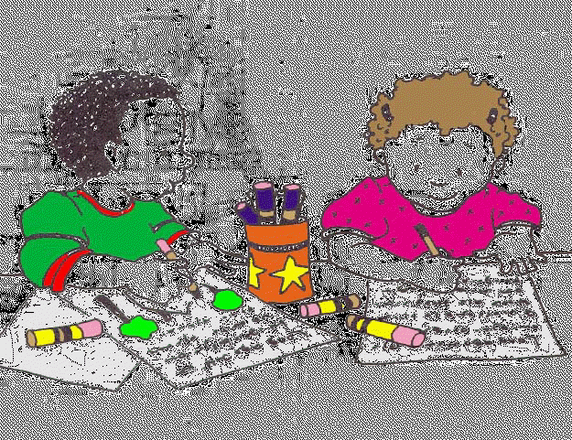](http://www.google.co.uk/url?sa=i&rct=j&q=literacy&source=images&cd=&cad=rja&uact=8&ved=0CAcQjRw&url=http://hil.troy.k12.mi.us/staff/bnewingham/myweb3/literacy_centers%20Final.htm&ei=bayfVdirI7SM7AaNu6aYCA&psig=AFQjCNH6jXNof7o_woqd2_LH3jiglIRdhA&ust=1436614029332857)

Helping your child with reading.

Reading with your child is vital. Research shows that it's the single most important thing you can do to help your child's education. It's best to read little and often, so try to put aside some time for it every day.

Think of ways to make reading fun - you want your child to learn how pleasurable books can be. If you're both enjoying talking about the content of a particular page, linger over it for as long as you like.

Books aren't just about reading the words on the page, they can also present new ideas and topics for you and your child to discuss.

Tips for helping your child to enjoy books:

Encourage your child to pretend to 'read' a book before he or she can read words.

Visit the library as often as possible - take out CDs and DVDs as well as books.

Schedule a regular time for reading - perhaps when you get home from school or just before bed.

Look for books on topics that you know your child is interested in - maybe dragons, insects, cookery or a certain sport.

Make sure that children’s books are easily accessible in different rooms around your house.

1. [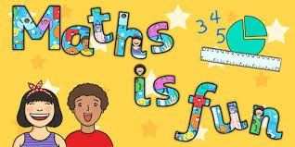](http://www.google.co.uk/url?sa=i&rct=j&q=maths&source=images&cd=&cad=rja&uact=8&ved=0CAcQjRw&url=http://www.twinkl.co.uk/resources/numeracy-maths/general-numeracy/3&ei=Ra2fVYjEFaW27gbVvZSwBA&psig=AFQjCNGXg5ECD-VjXm6GriBNqRwf8EwnrQ&ust=1436614312822369)

Helping your child with maths.

As with reading, try to make maths as much fun as possible - games, puzzles and jigsaws are a great way to start. It's also important to show how we use maths skills in our everyday lives and to involve your child in this.

Identifying problems and solving them can also help your child develop maths skills. If you see him or her puzzling over something, talk about the problem and try to work out the solution together.

Don't shy away from maths if you didn’t like it at school. Try to find new ways to enjoy the subject with your child.

Tips for helping your child to enjoy maths:

Point out the different shapes to be found around your home.

Take your child shopping and talk about the quantities of anything you buy.

Let your child handle money and work out how much things cost.

Look together for numbers on street signs and car registration plates.